**HRIS Data Mart and PowerBI Reports**

**Daily Maintenance Operation Instruction**

Contents

1. Background 2

2. Subscribe job monitor report to email 2

2.1 Monitor report location 2

2.2 Subscribe to email 3

2.3 Check email 3

2.4 Find job status 4

2.5 Action basing on job status 4

3. Re-run ETL job 4

3.1 Login to DWH SQLServer database 4

3.2 View Job Activity 5

3.3 Dig into job history 5

3.4 Find error details 5

3.5 Error fix 6

3.6 Re-run ETL job 6

3.6.1 Find the job 6

3.6.2 Re-run the ETL job from different steps 7

4. Refresh PowerBI datasets manually 7

4.1 Login to PowerBI website and pickup workspace 7

4.2 Refresh datasets one by one 8

| **Version Number** | **Version Date** | **Revised By** | **Description** | **Filename** |
| --- | --- | --- | --- | --- |
| 1.0 | 30/11/2017 | Jerry Shen | Created |  |
|  |  |  |  |  |
|  |  |  |  |  |

# Background

To keep HRIS PowerBI reports accurate and refresh daily, there are two separate automatic backend jobs running every day

* ETL jobs: extract data from TechOne – transform data in DWH – delivery to front tables
* PowerBI reports refresh job: automate job to refresh datasets and end users can see the latest data

From maintenance perspective, we need to make sure these above two jobs run successfully every day before 8:30AM.

If there are some errors happen in either of the two jobs, we need to investigate and fix them.

# Subscribe job monitor report to email

There is a report in PowerBI which is monitoring ETL jobs and you can subscribe it to your Anglicare email daily

## Monitor report location

* Login to PowerBI website: <https://app.powerbi.com>
* Go to IT workspace and find report named as ‘**SQLServerETLJobMonitor**’

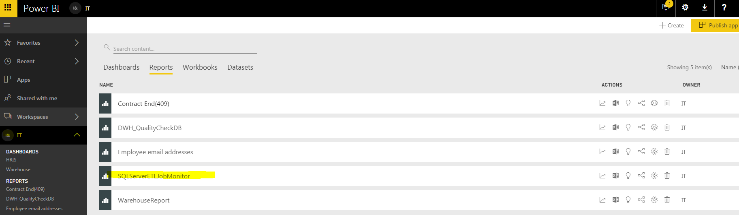

## Subscribe to email

* Open the report and click ‘Subscribe’ button – at the right top corner



* Add subscription and save

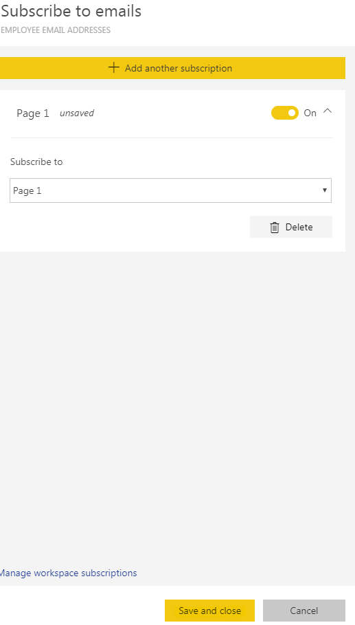

## Check email

After the above subscription process, you will get the report daily by email.

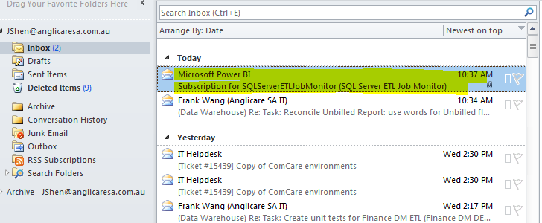

## Find job status

Open the email and you can find the ETL job status for HRIS data mart.

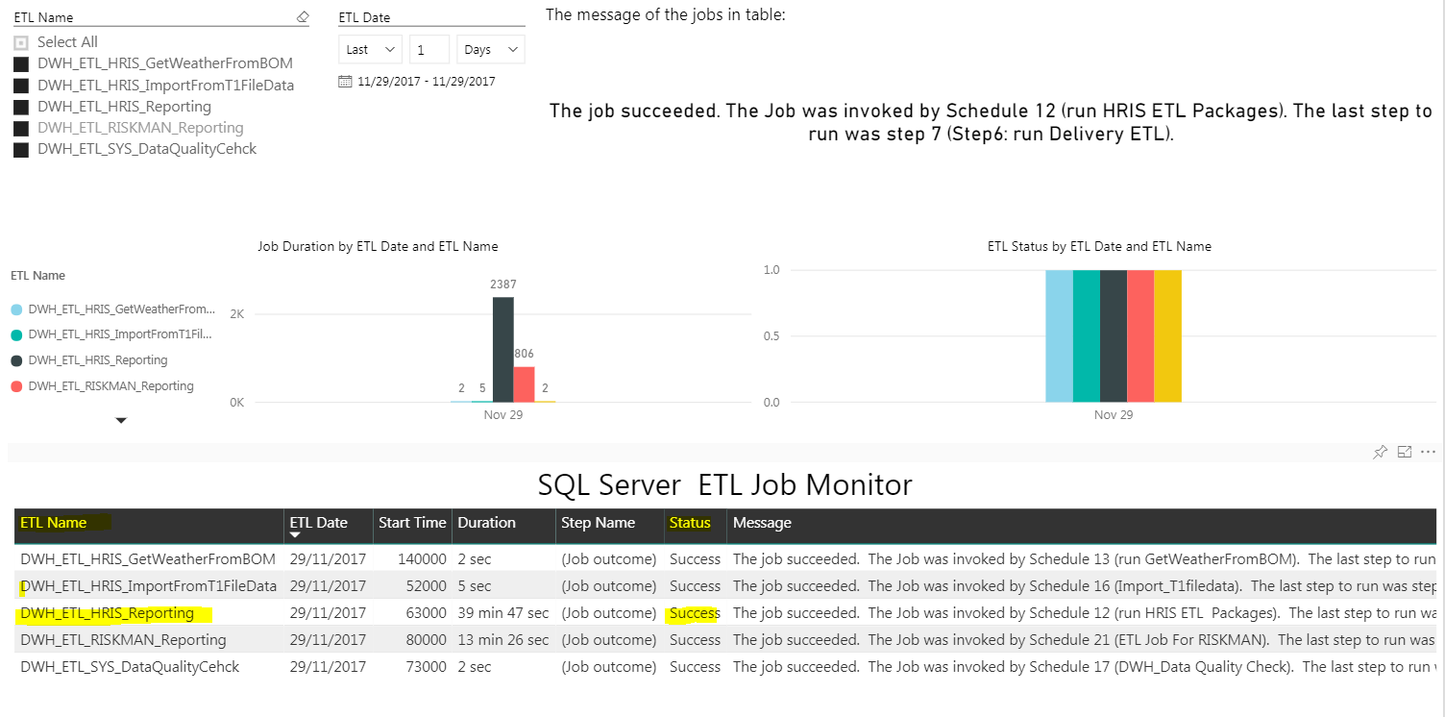

Note: you also can see all the ETL jobs for other data mart in DWH production environment.

## Action basing on job status

* If Success, nothing need to do
* If failed, go to next step to maintain ETL job

# Re-run ETL job

## Login to DWH SQLServer database

Server name: az-sqlbi01

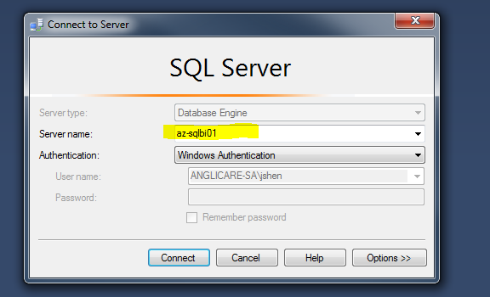

## View Job Activity

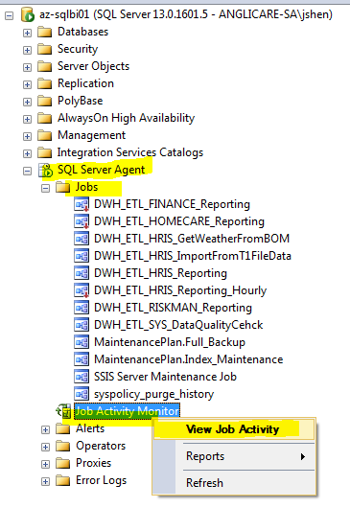

## Dig into job history

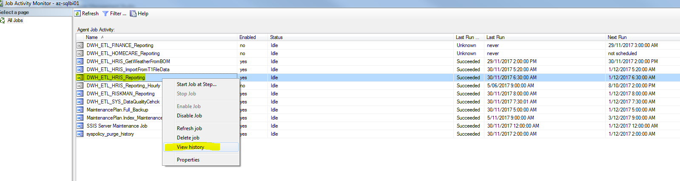

## Find error details

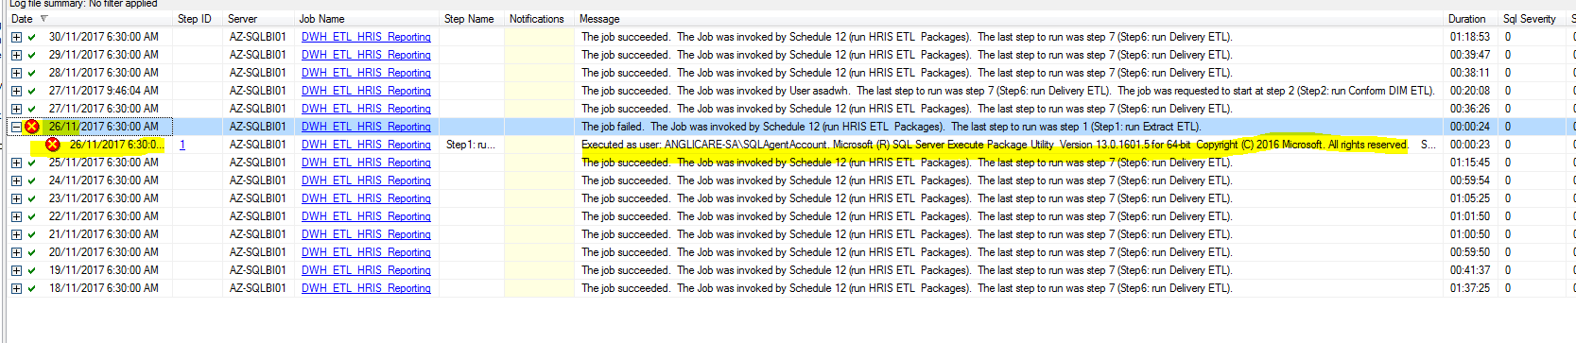

## Error fix

Check the error details and try to fix them

* If the errors are related with development, forward the error to DWH development team to fix.
* If just network connection errors, etc, just move to next step and re-run the ETL.

## Re-run ETL job

### Find the job

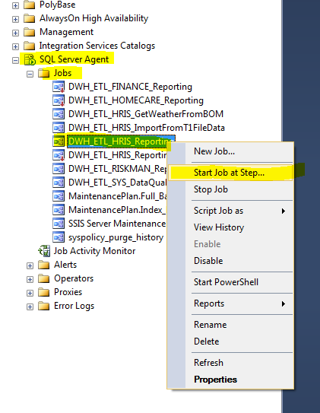

### Re-run the ETL job from different steps

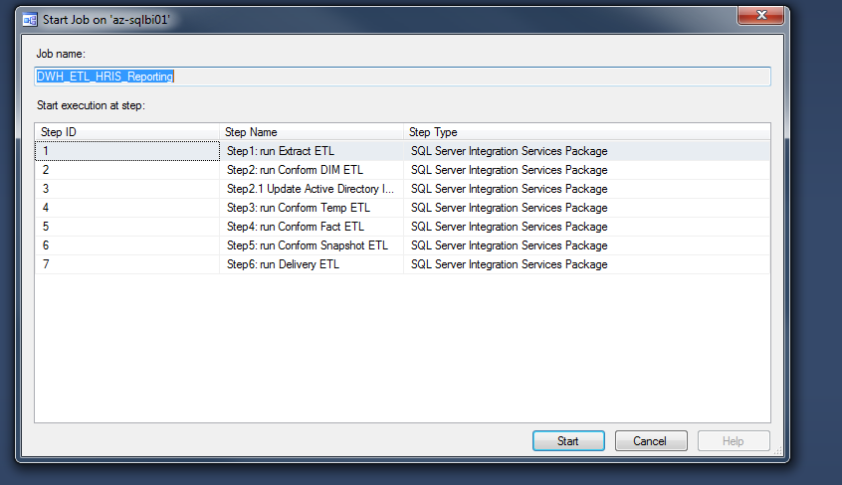

* If error happened at Extraction step, we need to re-run the ETL from step1: run Extract ETL
* If extraction step is ok, then you can start from Step2: run conform DIM ETL.
* After re-run, check the status again.

# Refresh PowerBI datasets manually

After re-run ETL, we need to refresh PowerBI data sets manually.

## Login to PowerBI website and pickup workspace

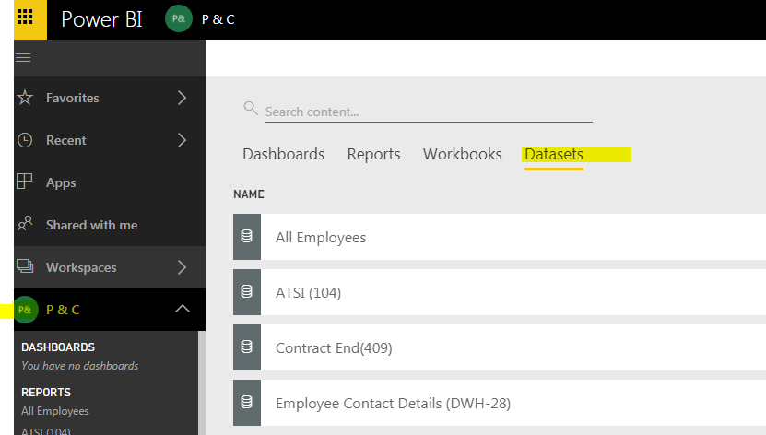

## Refresh datasets one by one

